Professional Development Workshop # 6: Unit Creation and Introduction to Templates

Speaker: Mrs. Lora Buchanan, NSF Program RET Coordinator
Date: Tuesday, June 18, 2019
Time: 1:00 – 2:30 PM
Venue: University of Cincinnati, Old Chem, room 841

Prepared by:
Lynn Brant, Kings High School, Kings Mills, Ohio
RET Participant for Project #4: “Signalized Intersection Design”

This session was given by Mrs. Lora Buchanan, coordinator for the RET Program, on Tuesday, June 18, 2019 from 1:00 – 2:30 PM at the University of Cincinnati in Old Chem, room 840. Lora began the RET program by giving a brief introduction to her diverse career. She earned a BS in Chemistry at Northern Kentucky University and a Masters in Secondary Education from NKU, as well as, a Masters in Administration from Xavier University. She is a high school science teacher at Oak Hills High School having taught there since 2008. She has served as a lead teacher in various mentoring roles for Oak Hills. From 2004-2008, Lora was a Chemistry teacher for Conner High School in Boone County. In addition, she was a chemist for The Procter and Gamble Company. She worked in upstream paper making for most of her 7-year career at P&G.

Mrs. Buchanan opened her session by presenting her objectives for unit creation and introduction to templates. Participants were given resource binders on the first day of the program, see Figure 1. Mrs. Buchanan’s session gave an overview of the resources provided in the “Unit Related” section of the binder and discussed the components necessary in the creation of the teaching unit for the summer project.

Figure 1: Mrs. Buchanan navigating participants through binders

Mrs. Buchanan started her discussion of templates by testing participants’ current knowledge of the Challenge-Based Lesson design through a paper/pencil pre-assessment. Questions included the following concepts:
- Unit template has two main parts.
- Proper teaching strategy sequence for a Challenge is big idea, hook, essential question, and challenge with academic content standards injected
- Constraints are the conditions or restrictions placed on the implementation of the Challenge.
- One unit is composed of 2 lessons with 2 activities each.

After the pre-test, Lora Buchanan shared a completed Unit Lesson from Kelly Lindsey, RET participant 2018. Through analysis of her lesson on “Building a Better Tunnel,” participants were able to grasp a stronger command of the Unit’s two parts. This summer, participants will complete the “Design the Unit” section and then following the challenge-based lesson in the classroom the second part “Post Implementation – Reflection on the Unit” will be completed.

Mrs. Buchanan and participants then had a discussion about the instructional implications of using the engineering design process and challenge-based learning. It centered around collecting information about the students learning with pre and post tests along with having students keep track of their own progress toward finding a solution.

After a thorough exploration of the unit format, Mrs. Buchanan directed the participants’ attention to the lesson’s Activity Template, see Figure 2. Several participants had concerns about timing of the unit with required state testing or the design of the project in the college classroom. Mrs. Buchanan provided clear examples and explanations about how the tasks could be completed.

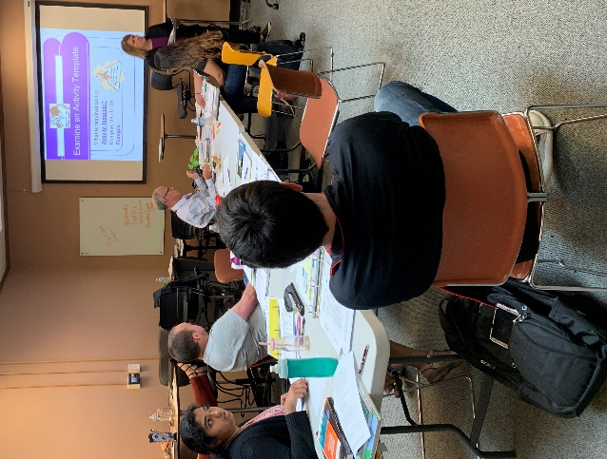

Figure 2: Mrs. Buchanan Explaining the Activity Template

The professional development session ended with Mrs. Buchanan reviewing the pre-test questions. She then encouraged participants to use their faculty mentors and graduate research assistants to brainstorm ideas throughout the summer. In conclusion, she expressed that she would gladly sit down with any of the participants to offer guidance on anything that was needed throughout the summer and the upcoming school year.

